**DAILY ONLINE ACTIVITIES SUMMARY**

|  |  |  |  |  |  |  |  |  |
| --- | --- | --- | --- | --- | --- | --- | --- | --- |
| **Date:** | **22/05/2020** | | | | | **Name:** | **Chandana Patil** | |
| **Sem & Sec** | **6th Sem and A Sec** | | | | | **USN:** | **4AL17CS020** | |
| **Online Test Summary** | | | | | | | | |
| **Subject** | | **Operation Research** | | | | | | |
| **Max. Marks** | | **30** | | **Score** | | | **30** | |
| **Certification Course Summary** | | | | | | | | |
| **Course** | **Introduction to Ethical Hacking** | | | | | | | |
| **Certificate Provider** | | | **greatlearning** | | **Duration** | | | **6 Hours** |
| **Coding Challenges** | | | | | | | | |
| **Problem Statement:**  **1.** Write a Java Program to separate the Individual Characters from a String.  **2.** Write a Java Program to find the largest and smallest word in a string. | | | | | | | | |
| **Status: Completed** | | | | | | | | |
| **Uploaded the report in Github** | | | | | **yes** | | | |
| **If yes Repository name** | | | | | **https://github.com/chandanapatil/OnlineCourse.git** | | | |
| **Uploaded the report in slack** | | | | | **Yes** | | | |

**Online Test:**

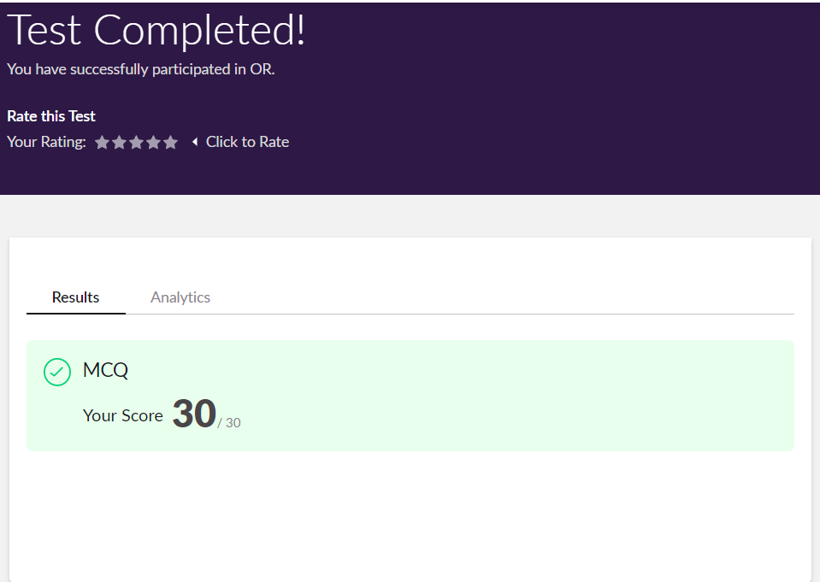

**Certification:**

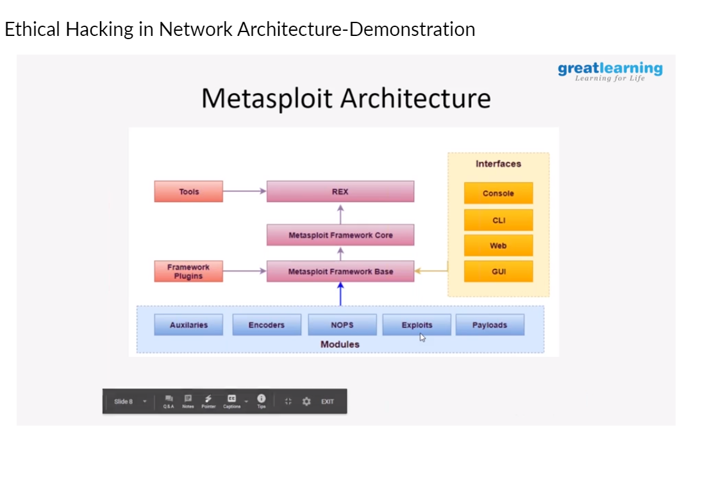

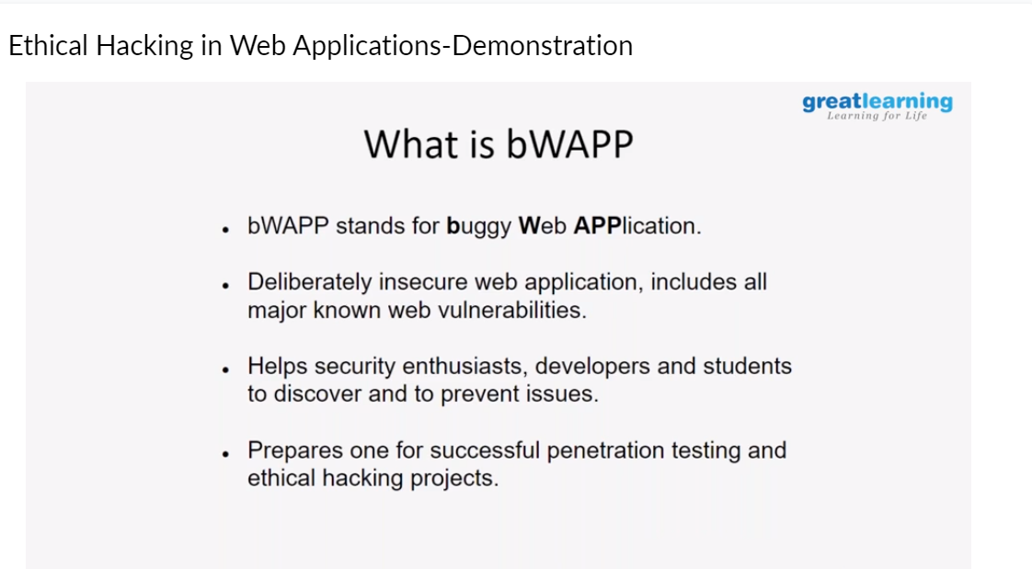

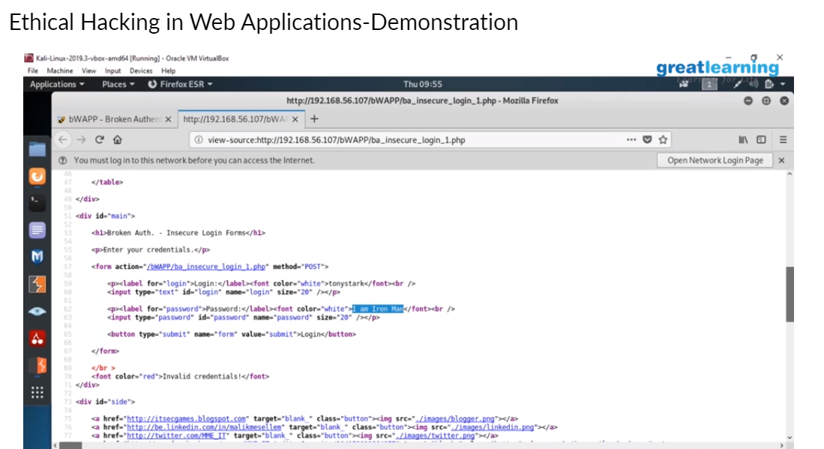

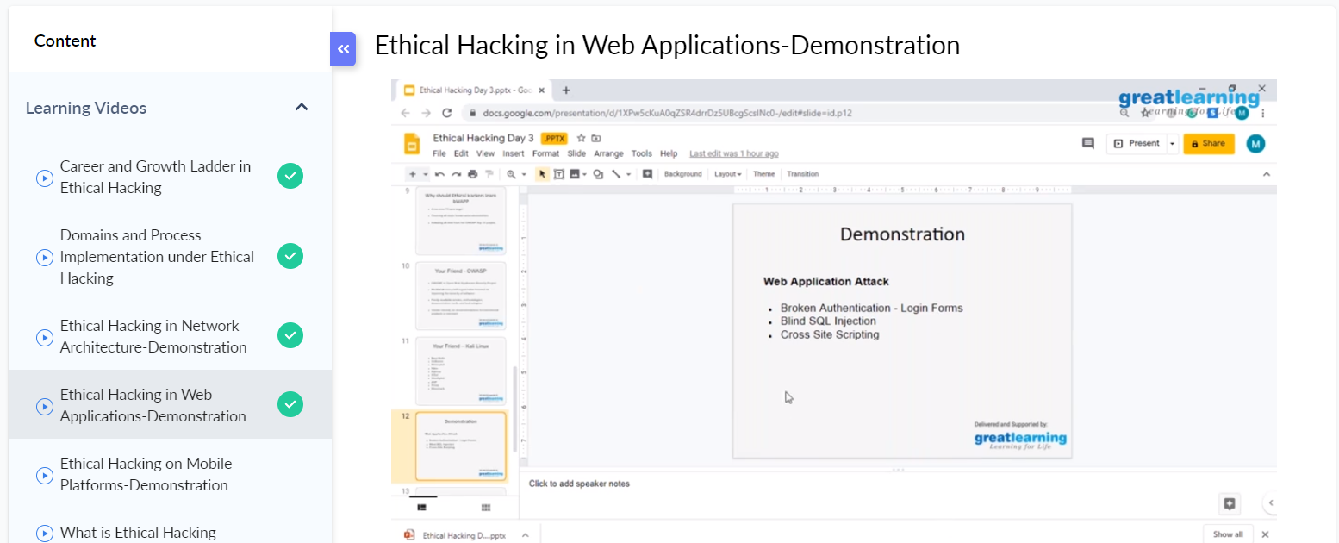

**OnlineCoding:**

**Prog1:** Write a Java Program to separate the Individual Characters from a String.

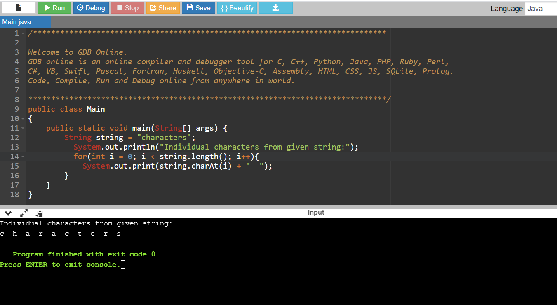

**Prog2:** Write a Java Program to find the largest and smallest word in a string.

